# **UNIT 6 : AFTER SCHOOL**

**B. Let’s go Period 5: ( B3 )**

I. Vocabulary:

- Wedding /ˈwed.ɪŋ/ (n): đám cưới

-Join /dʒɔɪn/ (v): tham gia, tham dự

**II. Model:**

***Would you like to … ?***

**EX :** ***would you like to have a drink ?***

( mời bạn đi uống nước )

**Notes :** đây là cách mời thông dụng nhất, ngoài ra chúng ta có thể sử dụng cấu trúc thân mật hơn.

***Why don’t you . . . ?***

***What about . . . ?***

Accept the invitation:

Yes, I’d love to .

That would be great fun.

Refuse the invitation.

I’d love to but I’m sorry, I can’t.

You are welcome.

It’s my pleasure.

TASK 1: Listen and choose True or false

|  |  |
| --- | --- |
| STATEMENTS | TRUE or FALSE? |
| **1. Next Sunday is Nga’s birthday.** |  |
| **2. Nga invites Lan and Hoa to come to her house for dinner.** |  |
| **3. Nga invites Lan and Hoa to go to see a movie.** |  |
| **4. Lan and Hoa will come to Nga’s house for lunch.** |  |
| **5. Hoa is going to a wedding on Sunday.** |  |

TASK 2:Listen. Then practice with a partner. Make similar dialogues: (text book)

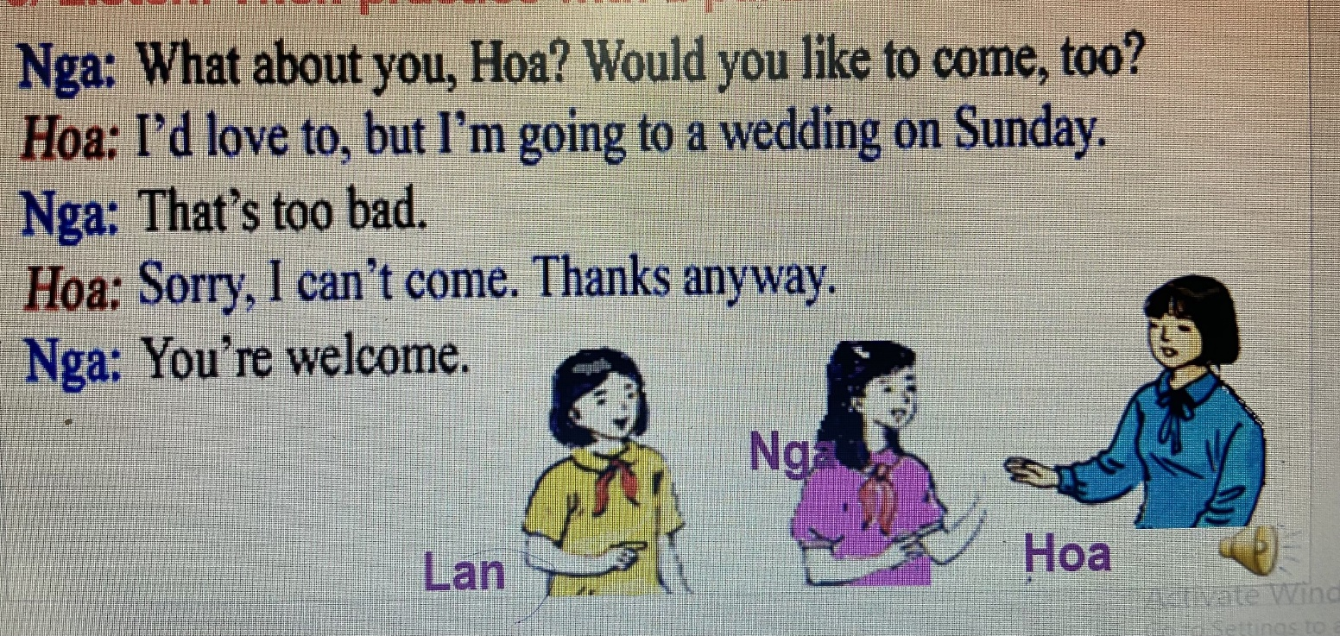

TASK 3; Practice the dialogue

**Nga: It’s my birthday on Sunday. Would you like to come to my house for lunch ?**

**Lan :Yes, I’d love to . What’s time ?**

**Nga: At one o’clock.**

**Lan: I’ll be there .**

**Nga: I’ll see you on Sunday.**

**Nga: After lunch. We’re going to see a movie . Will you join us ?**

**Lan: I’m not sure. I will call you tomorrow.**

**Nga: OK.**

**Lan: Thanks for inviting me.**

**Nga: It’s my pleasure.**

**Nga: What about you , Hoa ? Would you like to come ,too ?**

**Hoa: I’d love to, but I’m going to a wedding on Sunday.**

**Nga: That’s too bad.**

**Hoa: Sorry , I can’t come .Thanks anyway.**

**Nga: You’re welcome.**

Homework:

Learn the vocabulary by heart.

Learn by heart : ***Would you like to … ?***

***Why don’t we…..?***

Do exercise in workbook.

Prepare B4,5